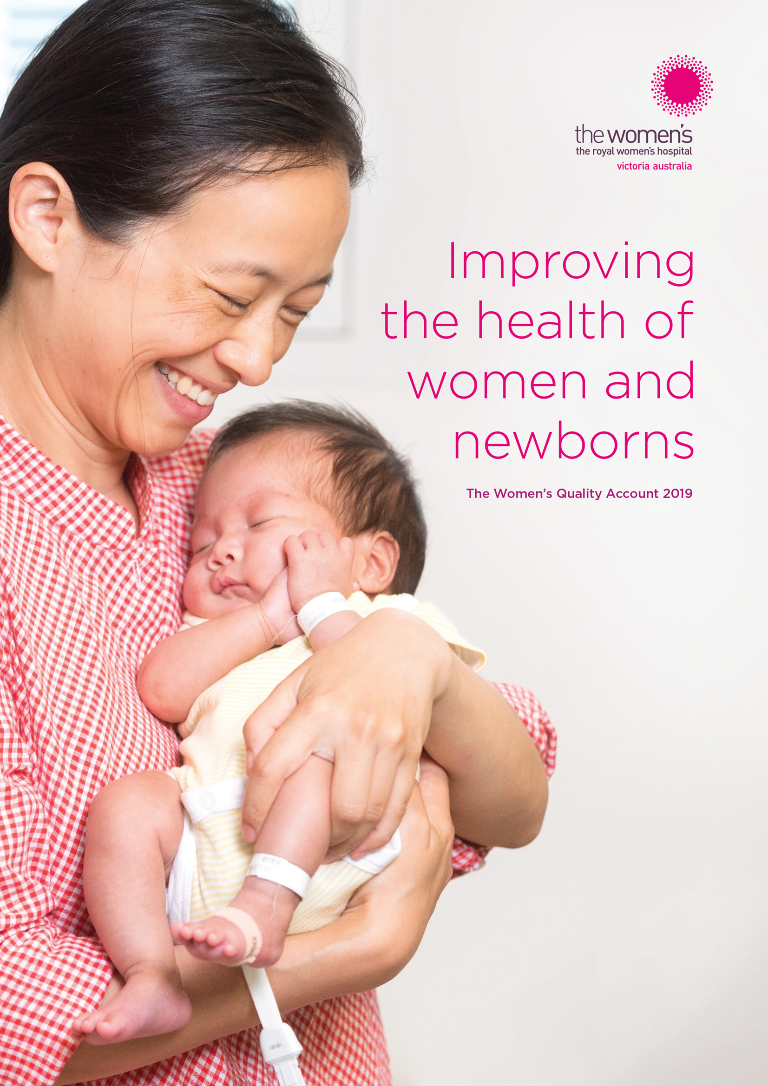
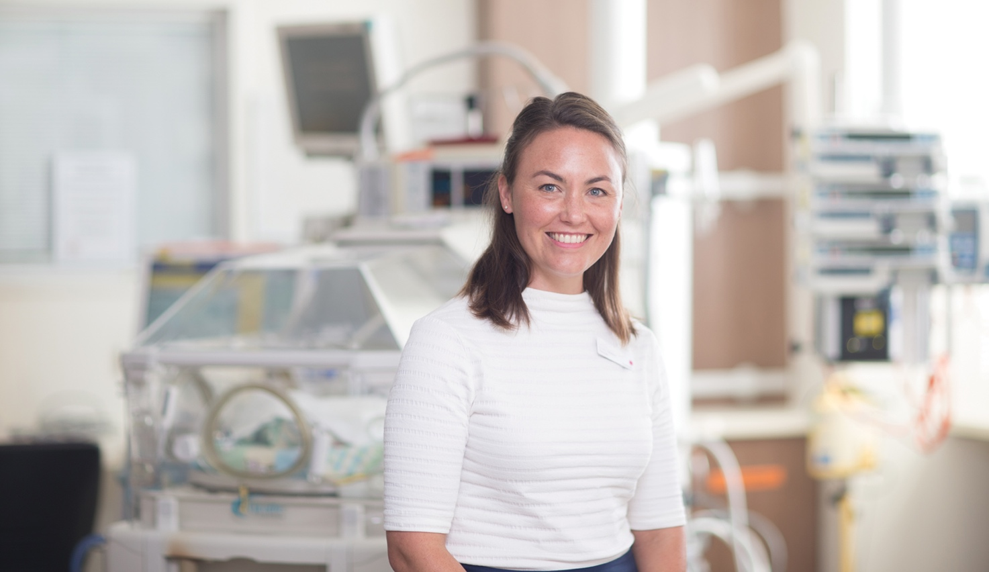
About the Women’s
The Royal Women’s Hospital is Australia’s first and largest specialist hospital dedicated to improving the health of women and newborns. The Women’s leads the way in women’s and newborn healthcare and has advocated and advanced issues of women’s health in Australia for more than 160 years.
We are recognised as a high performing healthcare provider with a reputation for excellence and innovation. Located at two sites, Parkville and Sandringham, the Women’s provides healthcare for local women and their newborns as well as those with complex needs from across Victoria. As a state-wide tertiary hospital, we have a unique role as a leader and advocate, sharing our expertise in specialist maternity, neonatal, gynaecology and women’s cancer care across Victoria and beyond.
The Women’s is a major teaching hospital, internationally recognised for our research and as a source of trusted health information for women and health professionals. We are a significant provider of training, professional development and secondary consultations to midwives, nurses, general practitioners and other specialists. Many practitioners and researchers from around Australia draw on our specialist expertise in areas such as pregnancy and substance use, women’s and newborn health research, women’s and infant mental health, and reproductive and sexual health.
The Women’s is committed to the social model of health, which recognises that a broad range of environmental, socioeconomic, psychological and biological factors impact on health, and we have a range of distinctive programs and services, offering support to women beyond clinical interventions.
Acknowledgement of Traditional Owners
The Royal Women’s Hospital acknowledges and pays respect to the peoples of the Kulin Nations, the traditional owners of the country on which our sites at Parkville and Sandringham stand and we pay our respects to their Elders past, present and emerging. The Women’s is committed to improving health equity for Aboriginal and Torres Strait Islander women, children and families and we recognise the fundamental significance of cultural traditions, beliefs and connection to country for the health and wellbeing of Aboriginal and Torres Strait Islander peoples. We acknowledge the importance of kinship and family structures as a cohesive force that binds Aboriginal and Torres Strait Islander peoples and we recognise their cultures, community connection, and self-determination as critical protective factors for wellbeing.

About this report
The Quality Account is for you – members of our community, past and present patients, consumers, families, visitors, volunteers and staff – to help you understand the quality and safety of the healthcare we provide at the Women’s. It highlights our performance, actions and achievements against quality indicators and standards that all public health services across Victoria must report on. All data relates to the 2018/19 financial year unless otherwise specified.
Provide us with feedback
To help us continually improve our services and care for women and families, we welcome your feedback. You can:
- Visit our website – thewomens.org.au/feedback
- Send us an email – Consumer.Liaison@thewomens.org.au
- Call us – 03 8345 2290
- Reach out via Facebook – facebook.com/theroyalwomenshospital
Partner with us
There are many ways you can be involved in partnering with the Women’s – join a working group or committee, share your story, review our health information, or participate in a focus group. We’d love to hear from you. You can:
- Send us an email – CommunityEngagement@thewomens.org.au


Contents
About the Women’s 2
About this report 3
Chair and Chief Executive’s message 4
The Women’s Declaration 4
Year in review 5
Partnerships: Providing exceptional patient experiences 6
Language no barrier 10
Supporting women of all abilities 11
Victorian Healthcare Experience Survey 11
Feedback improves quality and safety 14
Safety: Our people, patients, and culture 16
People matter most 16
Accreditation achieved 18
Sentinel and adverse events 18
Infection control 19
Victorian Perinatal Services Performance Indicators 19
Escalation of care processes 22
Embedding patient and consumer
perspectives in governance 23
Abbreviations and glossary 24

Chair and Chief Executive’s message
This report provides the community with an overview of our quality and safety performance as we strive to provide exceptional patient care. Key to this are our patients and consumers and the critical role they play in partnering with us so we can better understand their needs and perspectives as we continue on our journey of ongoing improvement.
Over the past 12 months, we have expanded our consumer partnership program: inviting members of the community to sit beside us at decision-making forums and on advisory groups; to provide us with real time feedback about our service and care; and to contribute their stories and views so we can learn.
As an example, in 2019 we created a new Patient and Consumer Experience Steering Committee. This committee brings staff, patients and consumers together to meet several times a year and provides advice and recommendations to the Women’s Community Advisory Committee and the Women’s executive team. We are also very pleased to welcome consumers to our Board Research Committee and our People, Culture and Engagement Committee, and we have increased the number of consumer members on our Board Quality and Safety Committee.
This year, Aboriginal and Torres Strait Islander and non-Indigenous staff drafted our Reconciliation Action Plan. This plan will form part of our broader approach and commitment to diversity and to ensuring greater access, equity and inclusion for all our patients, consumers and staff. As part of this commitment, we also developed our Disability Action Plan for 2019-2021. This plan was co-created with our Disability Advisory Group, which was formed in 2019 and includes staff, patients and consumers with disability who are committed to ensuring the Women’s is a safe, inclusive and accessible hospital and workplace.
From a precinct perspective, we’ve had an incredibly busy year collaborating with our Parkville partners to design and deliver the Connecting Care electronic medical record (EMR), due to go live in May 2020. This clinical improvement program is the largest of its kind in Australia and will not only transform patient care but increase our capacity to measure and improve. Pleasingly, the Women’s led the way in establishing a framework within the EMR program that has enabled patients and consumers to be involved across all program phases, attending build, design and review sessions, and sitting as members of governance bodies, including the Patient Confidentiality Working Group and the Patient Portal Advisory Group.
And finally, we are proud to continue to achieve strong positive results in the Victorian Healthcare Experience Survey, particularly in the ‘overall patient experience’ category, across all three areas in which the Women’s performance is measured – Adult Inpatient, Adult Emergency and Maternity.
We are always striving to make our health service better, and now, more than ever, patients and consumers are helping us to identify areas for improvement and working with us to develop solutions. These partnerships are shaping the care we provide today. But more importantly, the relationships we form with patients and consumers now are having a fundamental impact on how we think about the future, influencing the very care models we are currently designing and transforming the future of women’s and newborn health in the decades to come.
We are pleased to present the Women’s Quality Account 2019; as always, we welcome your suggestions and feedback.


Ms Lyn Swinburne AO Dr Sue Matthews
Board Chair Chief Executive

The Women’s Declaration
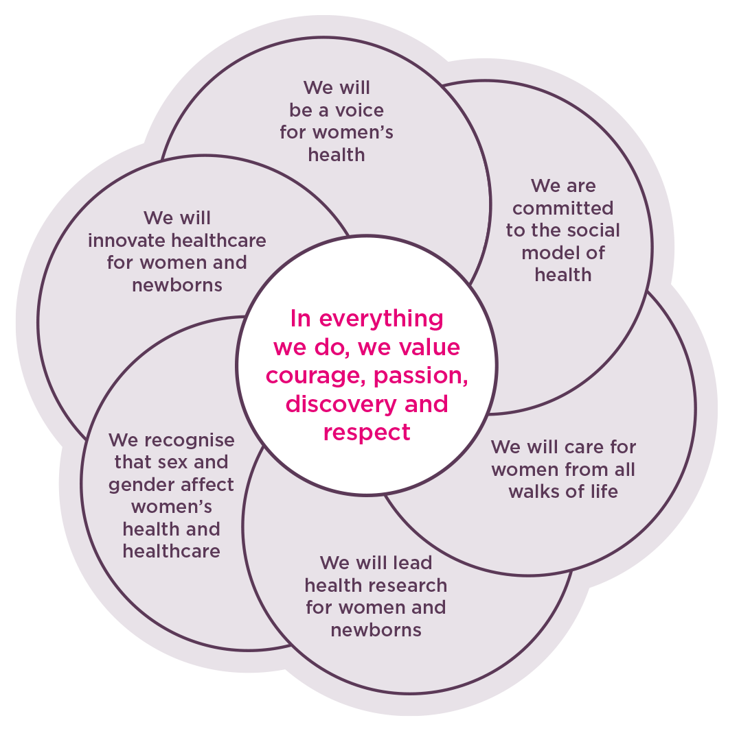
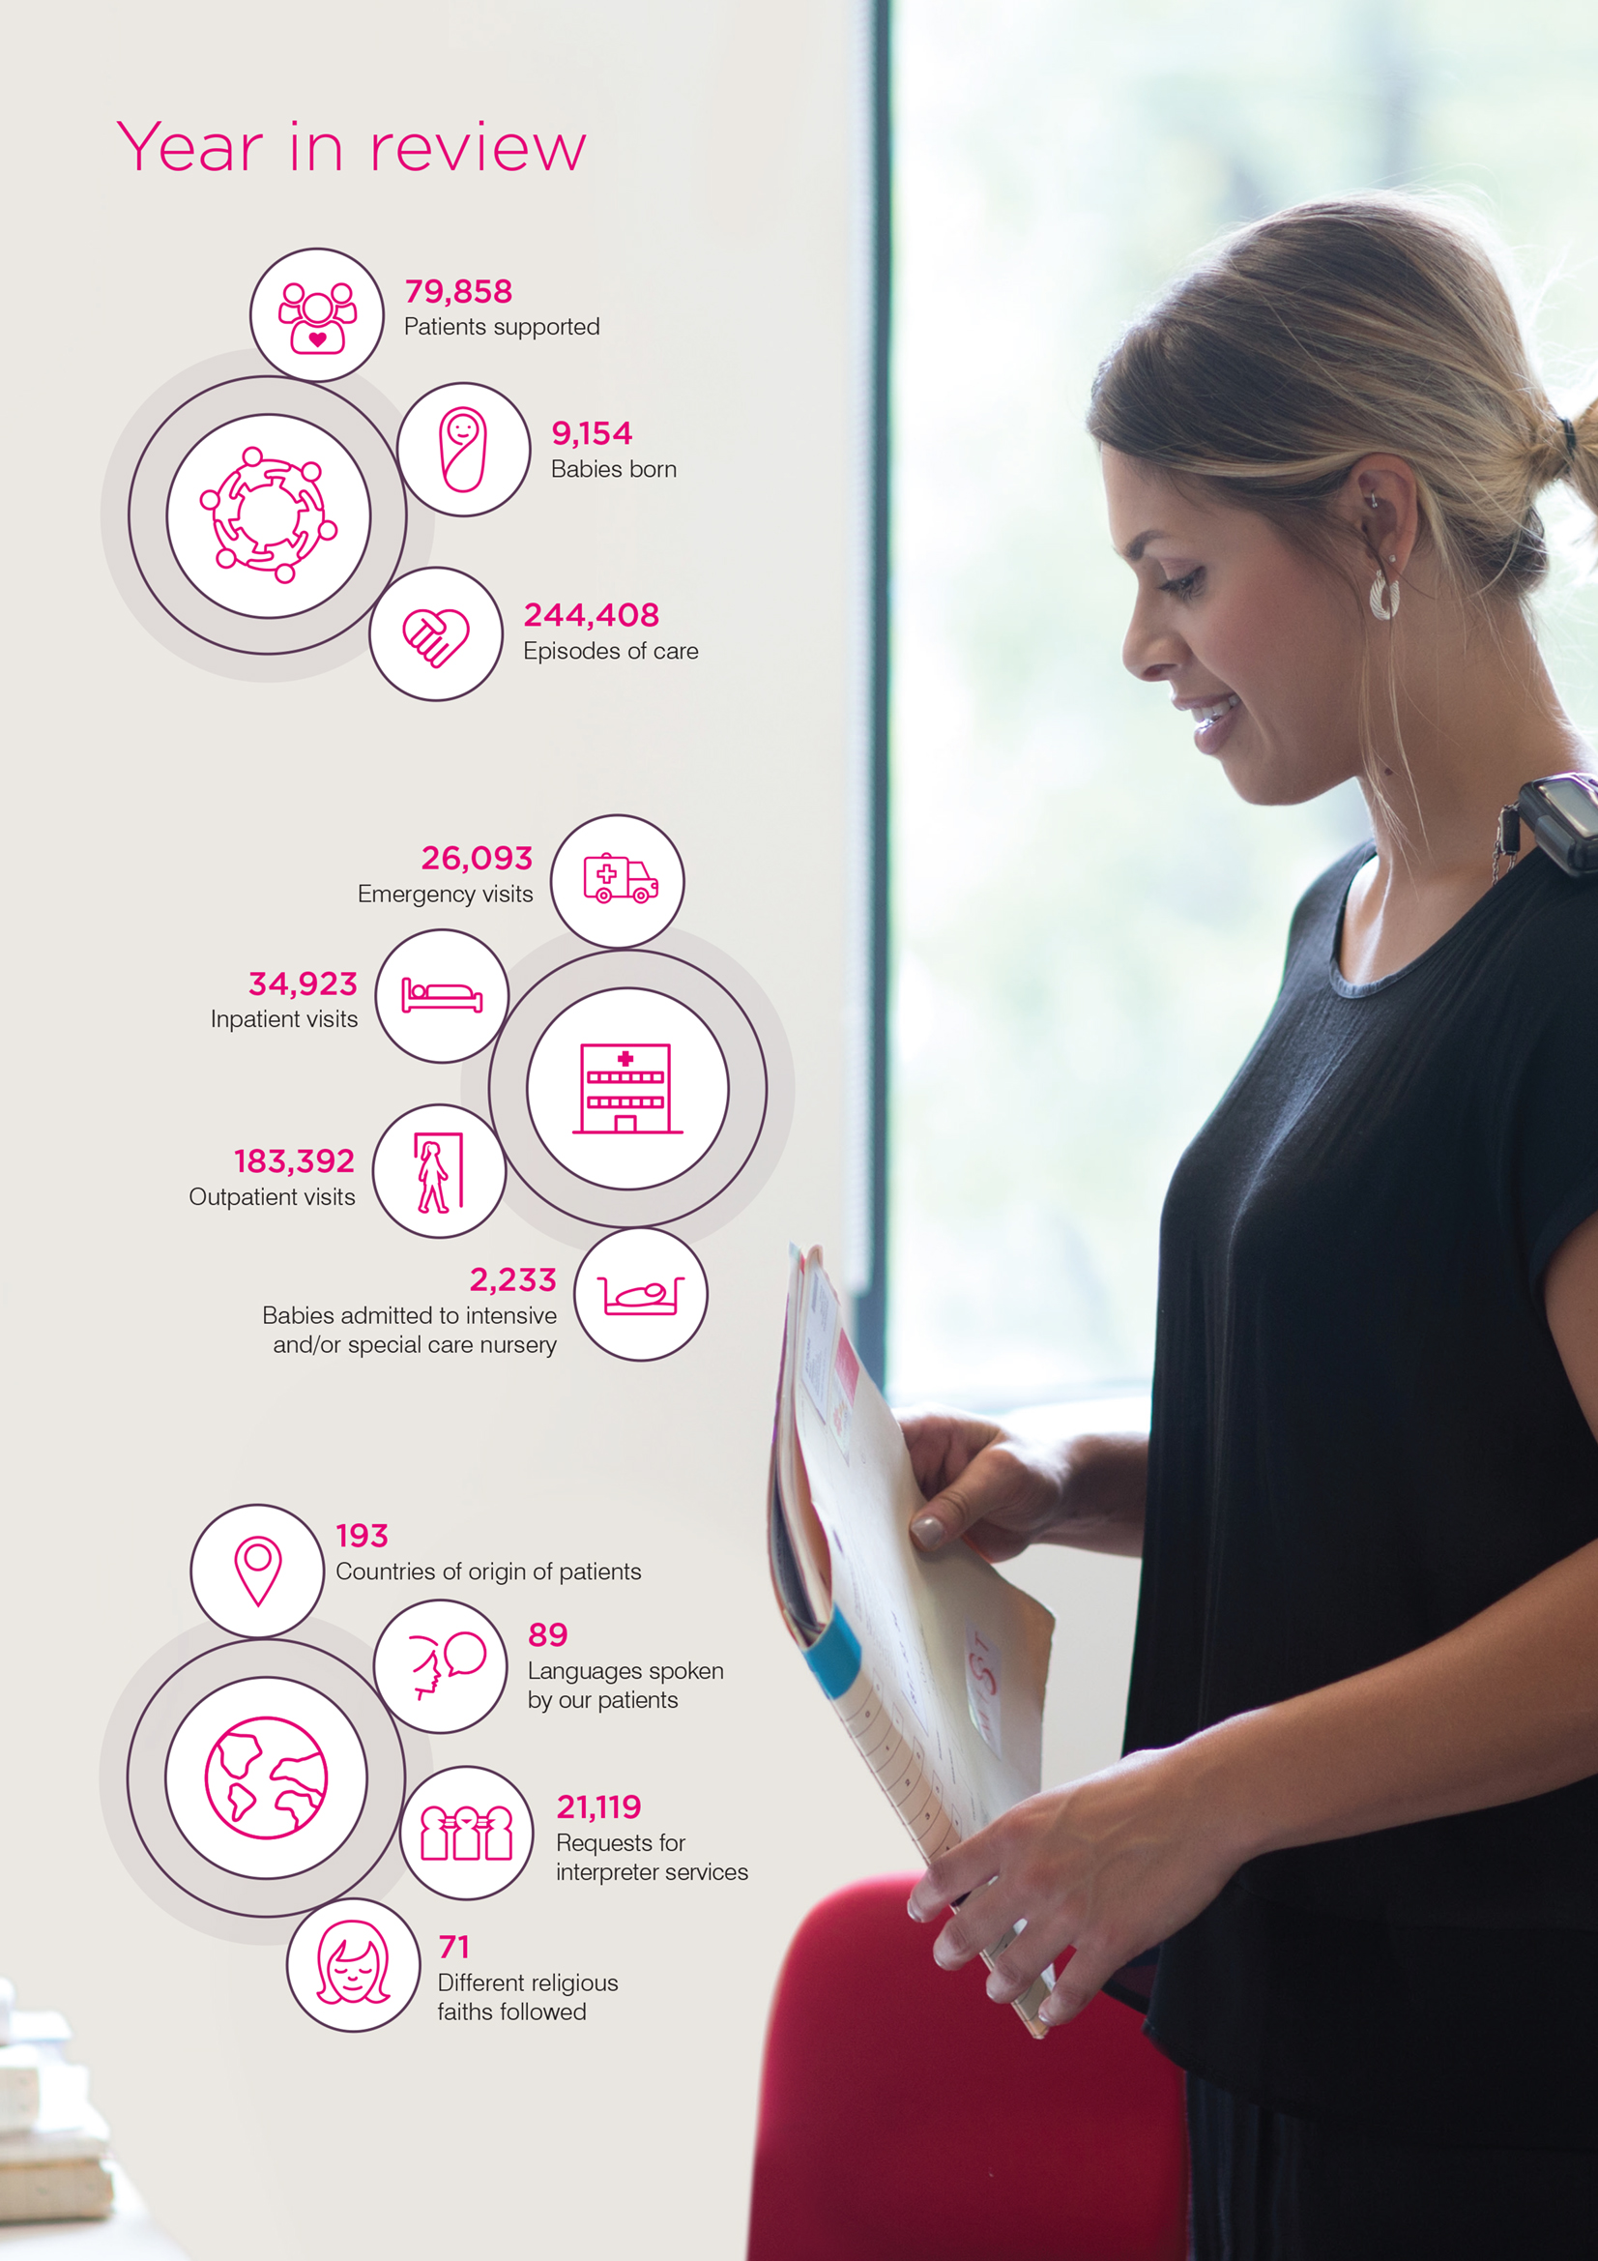

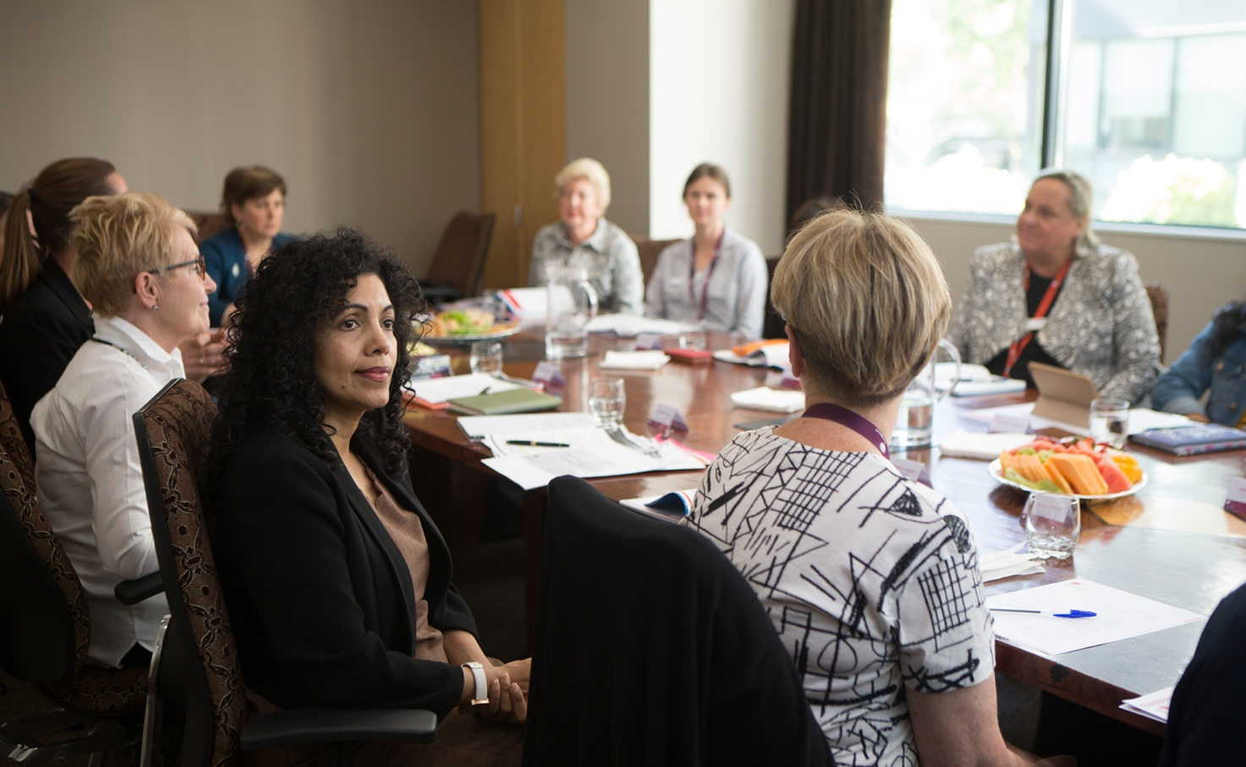
Partnerships: Providing exceptional patient experiences
Partnering with patients, consumers, carers and community members in every aspect of our service is fundamental to the Women’s approach to care.
Staff and patients collaborate and make shared decisions in everything from their own individual patient care, through to helping to shape and improve the future experiences and care for other patients and consumers.
Over the past year, the Women’s has partnered with thousands of patients and consumers in all kinds of ways, including through focus groups, surveys, working groups, committees and other initiatives to help further improve our systems, processes, services and quality of care. As a result, consumer representation across governance, committees and working groups has risen substantially.
We are very proud of the work we have done in this space and pleased to have attained special mention for our work in this area during accreditation by the Australian Council on Healthcare Standards in March.

We regularly measure our performance and use all information available to us so we can continuously improve. Our focus going forward will be on strengthening our partnerships with patients and consumers through communication and shared decision-making.
Throughout 2018/19, our staff, patients and consumers have co-designed some of our most significant improvement programs, bringing us closer to achieving our commitment to transform healthcare for women and newborns. Some of these initiatives are outlined in this section.
Creating Exceptional Experiences program
More than 800 staff members from across all teams at both Parkville and Sandringham have now graduated from our Creating Exceptional Experiences (CEE) program – a ten-hour course conducted over five weeks that reinforces the importance of listening to understand, reflecting on our assumptions and judgements, and respecting the expertise that patients and consumers bring to the partnership.
Patient feedback near real time
In April, we began sending a short survey to some of our patients soon after they were discharged from hospital. This survey, initially trialled in a few clinical areas, including theatre and day surgery, is the first step in a feedback loop designed to give us more regular and timely insights into patients’ experiences.
This will enable us to acknowledge and celebrate great care by our teams, learn from feedback, and implement improvements as swiftly as possible. This feedback program was co-designed with staff and consumers and we look forward to gaining even more insights over the coming year.
Coordinating engagement
The Women’s full-time Community Engagement Coordinator supports all areas of our organisation with the tools and capabilities to actively partner with patients and consumers, develop ongoing relationships, and nurture strong consumer and community engagement networks.
Training and education
Our Clinical Education team collaborates with a variety of consumer organisations, such as Ovarian Cancer Australia and Survivors Teaching Students (for sexual assault survivors) to involve consumers in staff training, education and professional development activities. Consumers are present at various training activities, including courses to support women and their families who experience reproductive loss.
Embedding the voice of patients and consumers
We collate and record patient and consumer stories throughout the year, and use them in professional development sessions, the CEE program, and at Board and other committee meetings. Stories are recorded in the consumers’ own voices whenever possible, which has the powerful effect of literally bringing the consumer experience and voice into the room, ensuring patient and consumer perspectives are incorporated into plans to deliver and improve healthcare at the Women’s.
Supporting clinicians to partner with patients
The Women’s has an extensive selection of health information resources that are used by clinicians to support shared decision-making with patients, as well as to support the health literacy of our patients. These resources are developed collaboratively with patients and consumers, who generally have lived experience of the topic area.
From health information to health literacy
We are extending our approach from building health literacy through patient information to creating organisational health literacy that makes it easy for everyone to find, understand and use the Women’s information and services.

We are doing this by furthering our workforce skill and knowledge, making our information and communications easier to understand, transforming delivery of care and services to be easier for patients and consumers to navigate, and creating more opportunities for consumer partnerships.
A patient’s level of understanding and literacy of their healthcare is an important factor in feeling empowered to participate in decisions – two core indicators tracked by the Victorian Healthcare Experience Survey (more on page 11).
Patient and Consumer Experience Steering Committee
In 2019, consumers, volunteers and Women’s staff formed a Patient and Consumer Experience Steering Committee. This committee is helping us deliver on our key strategic direction, which is to provide an exceptional patient and consumer experience that offers improved health outcomes for women and newborns. Meeting at least six times a year, the committee provides advice and recommendations on a number of patient experience topics to the Community Advisory Committee (a sub-committee of the Women’s Board), and the Women’s Chief eXperience Officer and her team.
“As a consumer, the Patient and Consumer Experience Steering Committee provides me with the opportunity to contribute to the strategic direction of the Women’s. Additionally, the committee provides the avenue to partner with staff at the governance level.”
– Consumer representative Deepa Mathews
Governance partnerships
During 2018/19, the Women’s undertook a review of governance partnerships across the organisation, resulting in a decision to increase consumer representation at this level. Consumers have joined our Board Research Committee and People, Culture and Engagement Committee, and the number of consumer members on our Board Quality and Safety Committee has increased.
Patient Experience Week
In April, we celebrated our second annual Patient Experience Week, recognising the role of our people in creating exceptional experiences with patients. Patients and the community played an integral part in the week’s activities, including as judges of our ‘Ideas Tank’ that awarded funding to initiatives that will improve staff and patient experience.
Embracing ideas for improvement
When it comes to improving patient experience and workplace culture, the Women’s staff, patients and families are often best placed to identify opportunities for improvement.
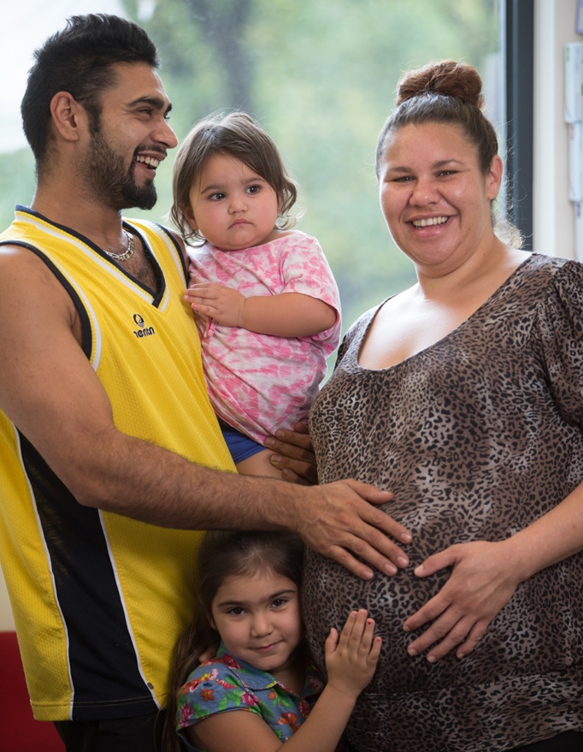
Our ‘Ideas Tank’ is one way we engage and empower staff to bring about change. In April, staff presented their ideas to improve the hospital experience of care for patients and consumers to a panel of judges, including consumer and staff representatives, our CEO Dr Sue Matthews, and representatives from the Royal Women’s Hospital Foundation, HESTA and BankVic, who provided $14,000 to help fund the winning ideas.
From 36 submissions, 11 ideas to improve patient experience were funded to proceed, including:
- using sound machines to help babies sleep better in our neonatal intensive care unit
- providing purpose-designed sleeping pods to create protection zones around a baby in bed
- installing warm compress stations in every birthing room to help prevent the incidence and severity of perineal tears during labour
- supplying equipment to decrease the likelihood of women recovering from reproductive loss hearing newborns cry in our hospital
- piloting smoking ceremonies for Aboriginal families who have experienced reproductive loss
- sourcing training equipment to help clinicians further develop dexterity skills in perineal tear repair
- developing resources to help patients understand the risks of alcohol and drug use on foetal development
- purchasing a computer tablet to enable women who have not been discharged to see, hear and talk to their babies who are inpatients at the Royal Children’s Hospital
- installing a phone charging bar in Day Surgery to allow patients to stay in touch with family during the day
- translating our Postnatal Education Plan – as well as key maternity terms – into the ten languages most commonly used by our patients and consumers.
Standing together with Aboriginal and Torres Strait Islander peoples
We are strengthening our commitment to working with Aboriginal and Torres Strait Islander women, families and communities to strengthen the health, safety and wellbeing of women and their babies.
We do this in many ways, such as through our
Badjurr-Bulok Wilam Aboriginal and Torres Strait Islander Women and Families Place, which provides a culturally appropriate support and advocacy service; and through the Women’s Reflect Reconciliation Action Plan 2019-2021.
This plan has been developed by Aboriginal and Torres Strait Islander and non-Aboriginal and Torres Strait Islander staff, with a focus on:
- Promoting culturally safe practices to ensure Aboriginal and Torres Strait Islander women and babies receive high quality, accessible, and culturally appropriate care
- Strengthening our relationships with Aboriginal and Torres Strait Islander women, Elders, communities and organisations
- Improving and increasing Aboriginal and Torres Strait Islander employment opportunities at the Women’s
- Increasing our organisational understanding of Aboriginal and Torres Strait Islander histories, cultures, customs, and identities.
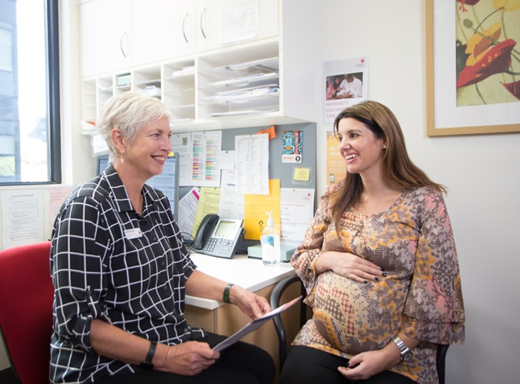
Shaping the future for all patients and consumers
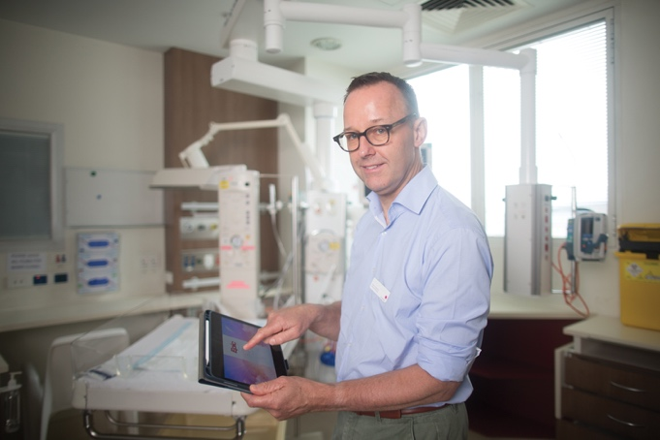
The Women’s is currently working with our Parkville hospital precinct partners, Melbourne Health, Peter MacCallum Cancer Centre and the Royal Children’s Hospital, to create a world-class electronic medical record (EMR) system. Working in partnership with Epic, a world leader in EMR technology, the Connecting Care EMR program is currently the largest clinical transformation project in Australia and will revolutionise patient care in Parkville.
The EMR will be introduced in May 2020 and will create a secure digital patient record that replaces current paper-based systems, making it easier for healthcare professionals to provide a streamlined and integrated experience for patients across the four hospitals, while creating improved quality and safety monitoring.
In a world-first for Epic, patients and consumers have been involved in the build of the EMR every step of the way, attending design and review sessions and sitting as members of governance bodies, including the Patient Confidentiality Working Group and the Patient Portal Advisory Group.
The EMR will also deliver a patient portal, to be available via mobile app or computer. It will enable patients to become active participants in partnership with their healthcare team – supporting them to be more involved in decisions about their care and treatment. Patients will be able to log in securely to schedule and view upcoming appointments, see appointment notes and test results, view their prescribed medications, and more.
Updating the model of care for Maternity Services in Parkville
Throughout last year, our clinical leaders have been working to update the model of care for Maternity Services at the Women’s in Parkville. The goal is to create a contemporary service that meets the changing needs and expectations of women while helping the Women’s to meet the challenges and opportunities coming our way as a tertiary hospital in a growing metropolitan city.
This involved a co-design process with our people, patients and consumers that included numerous workshops, surveys and consultations. Three consumers were at the table throughout the process and more than 350 women who had given birth at the Women’s contributed their thoughts through surveys.
Pleasingly, what women in our care think is important aligns well with what our staff think is important: choice for women, efficiency, standardisation, and flexibility – including options for accessing prenatal care outside our hospital. Overwhelmingly, continuity of carer was confirmed as a priority for all.
An additional outcome of the co-design process was that one consumer partnered with our Director of Maternity Services in the Collaborative Pairs Program. This is another partnership that trains clinicians and consumer pairs to be equal partners in creating organisational change.
Language no barrier
The Women’s cares for patients of all backgrounds, cultures and languages. Our Language Service is crucial to ensuring that all women, families and health professionals have the opportunity to understand each other and contribute to decisions that may affect patient health.
During 2018/19, our patients originated from 193 countries and spoke 89 different languages. We received
21,119 requests for interpreter services.
Ninety-five per cent of patients who received the service were assisted by a certified/accredited interpreter from the National Accreditation Authority for Translators and Interpreters (NAATI).
Our own team of interpreters provided a service for more than half of the requests, while another 40 per cent of requests for service were met by experienced interpreters from agencies who were booked to provide language assistance via face-to-face or telephone interpretation.

Of the five per cent of interpreter services that were not certified, most occurred because the language requested was either not one tested and/or certified by NAATI, or was a language for which only a limited number of certified interpreters are available.
We continue to see an increasing number of requests to support patients with languages not previously spoken at the Women’s. This year, these languages include Ewe, Karen Pow, Zomi, and some Aboriginal and Torres Strait Islander languages. It also remains challenging to source certified interpreters in some of the ‘old’ languages such as Greek, Russian, Italian and Polish, as experienced certified interpreters retire and there are fewer new ones replacing them.
Supporting women of all abilities
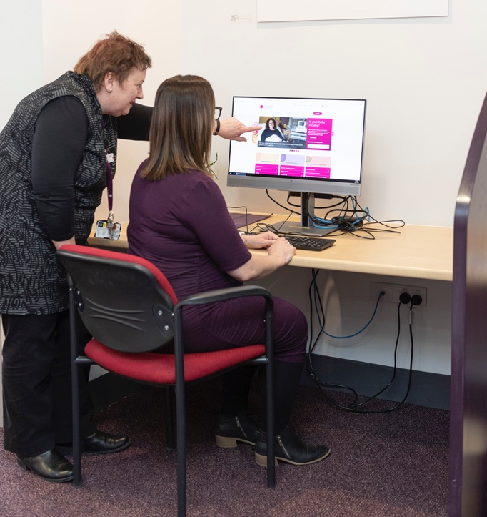
Over the past year, the Women’s has drafted a Disability Action Plan. This plan was co-created with our Disability Advisory Group, that was formed in 2019 and includes staff, patients and consumers with disability and a passion to ensure the Women’s is a safe, inclusive and accessible hospital and workplace.
The action plan was also informed by consultations with women with disability (via a focus group and an online survey), expert advice from Women with Disabilities Victoria (the Victorian peak body for women with disability) and findings from the Australian Network on Disability Comprehensive Access and Inclusion Audit.
This information forms the foundation for the Women’s policies, procedures and practices against ten key areas that have the greatest benefits for access and inclusion for people with disability in healthcare.
The Disability Action Plan will focus on:
- Ensuring our services, programs and hospital facilities are accessible to women with disability and their families
- Increasing opportunities for people with disability to obtain and maintain employment
- Promoting community inclusion and participation of people with disability
- Changing attitudes and behaviours which discriminate against people with disability.
Victorian Healthcare Experience Survey
The Victorian Healthcare Experience Survey (VHES) gathers feedback from patients who have recently attended Victoria’s public health services. The survey is conducted on behalf of the Department of Health and Human Services (DHHS) by an independent company and is distributed to a sample group of eligible, randomly selected participants.
Public health services receive the feedback data each quarter and we use this to identify trends, build on our areas of strength, celebrate improvement and set performance targets for the year ahead.
The DHHS targets for VHES for 2018/19 were:
- Overall experience: 95 per cent of Adult Inpatient respondents rated their overall experience as either ‘good’ or ‘very good’.
- Discharge care: 75 per cent of Adult Inpatient respondents to four specific questions about discharge care rated their experiences positively.
Patient experience score
We are proud to continue our trend over several years of achieving strong positive results in overall patient experience, across all three areas in which the Women’s performance is measured – Adult Inpatient, Adult Emergency and Maternity.
Our Adult Inpatient services performed well above the DHHS target and state-wide averages for three quarters of the year, ending on a particularly high note of 100 per cent in the April-June quarter. This result was influenced by very positive responses to questions relating to women feeling they were listened to and understood and feeling involved in decisions.
Our Women’s Emergency Care recorded higher than state-wide average results for three quarters of the year, with favourable scores influenced by increases in positive responses to questions around respect and dignity and listening and understanding.
Performance results for Maternity remained stable at 90 per cent or above throughout the year, with Sandringham recording an outstanding score of 100 per cent for overall treatment and care at the start of the year. Although there was a small decrease in our overall Maternity score over the course of the year, the driving factors that make up this score are stable or improving. For instance, most of our patients feel they receive help from our staff within a reasonable time and are treated with respect and dignity.
Our positive results can, as always, be attributed to our people and their dedication to caring for our patients and consumers. The most common patient comment across all areas related to the high quality of our emotional and interpersonal care.
We will continue to work on specific areas women would like to see us improve upon and, aligned to Safer Care Victoria’s Partnering in Healthcare framework, we will focus even more on working together and sharing decision-making.
Leaving hospital
VHES includes measures relating to how ready adult inpatients feel when they leave hospital. Questions include whether patients agree that:
- they have received enough information about managing their health and care at home
- their family and home situation has been considered
- adequate arrangements have been made for any services they might need at home
- their GP was provided with relevant information regarding their treatment and advice for follow up after their hospital stay.
The results of these questions combine to make an overall ‘leaving hospital’ score.
Over the past 12 months, we have consistently improved the experience of leaving the hospital, ending the year above target, by focusing on ensuring patients have accurate and timely information about what to expect before coming to hospital. Doing this helps patients to prepare for their hospital stay and build their awareness of what to expect when they are ready to leave.

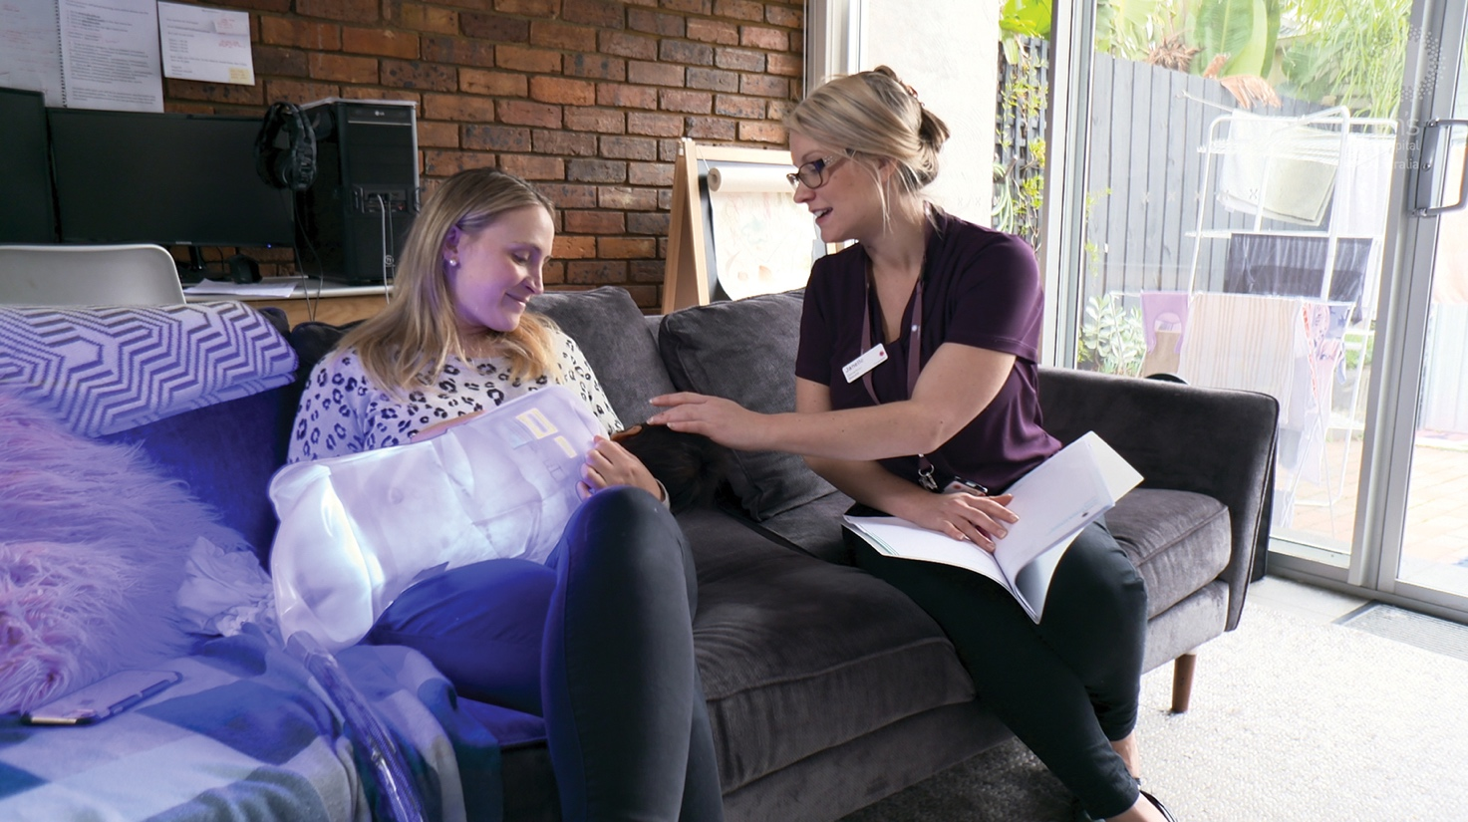
Supporting babies to settle in at home
A baby’s first week of life should be spent bonding with family, breastfeeding and settling in at home. But for some babies with jaundice (a common yellowing of the skin caused by high bilirubin levels in the blood) their first week can be filled with daily hospital visits, blood tests, waiting for results and then being admitted back into hospital for treatment.
Thanks to support from the Better Care Victoria Innovation Fund, the Women’s has implemented a new and improved way of assessing and managing jaundice in newborns in their homes.
Our midwives now screen babies for jaundice and collect blood tests during routine home visits. The blood is transported to hospital for testing and the midwife contacts the family with the results within a few hours.
Most babies with jaundice do not require treatment, but as extremely high jaundice levels can adversely affect the brain, sometimes bilirubin levels are high enough to need treatment.
Exposing the baby’s skin to blue light (phototherapy) helps break down the bilirubin until the baby’s liver takes over. To further support families to stay together at home, we introduced portable bilirubin blankets.
Families can now borrow our ‘bili blankets’ to provide phototherapy at home, with neonatal nurses attending daily to monitor the baby, measure bilirubin levels and support the family. Most babies can complete their jaundice treatment in the home in a few days.
This initiative has reduced presentations to our Women’s Emergency Care of babies with jaundice by 50 per cent, reduced maternity inpatient admissions to hospital, and, most importantly, provided a safe, supportive and convenient care option to keep babies at home with their families.
“The midwife and nurses were very helpful, they took us over how to use the Bili blanket at home in detail and carefully assessed our baby. By far the biggest positive aspect was being able to treat baby at home. As a first time mum it was an extremely tough time, it was great to be at home as it felt safe and family was able to help out and provide emotional support.”
– Mother of baby who received phototherapy in the home, October 2018

Feedback improves quality and safety
Our Consumer Liaison team supports patients and consumers who need to discuss and resolve any concerns they may have with their care or experience at the Women’s. All interactions with our Consumer Liaison Officers are confidential and patient complaints are not included in the patient’s medical record and do not affect their current or future treatment and care.
The Consumer Liaison Officers are available to meet with patients and consumers in person during business hours and they are also contactable via phone, email or mail. They are skilled at listening to patients and providing support and advice to every individual in a professional and non-judgmental way. We promote our Consumer Liaison Service widely; on our website, through social media, and throughout the hospital using our “tell us what you think” brochures.
Most complaints to our service relate to clinical, relationship or operational issues. These are broad themes that cover many concerns such as patients seeking further information about their treatment and test results, the timing of appointments, or providing feedback about the clinicians caring for them. A common theme has been concern about communication with staff, including a lack of clarity of information provided during an appointment, or uncertainty around an ongoing care plan.
We make every effort to resolve issues at the earliest opportunity but on the occasions when a patient or consumer is not satisfied with the outcome, there are other avenues open to them to seek resolution, including getting in contact with the Health Complaints Commissioner.
We use all the feedback we receive through the Consumer Liaison Service to help us prioritise where to focus our quality improvement programs as we strive to always provide exceptional care for our patients and consumers.
A small number of episodes of care result in a complaint. During 2018/19, we delivered 244,408 episodes of care. By contrast, we received 542 complaints to our Consumer Liaison Service. Seventy-seven per cent of complaints were resolved within 30 days and less than one per cent were referred to the Health Complaints Commissioner.
Complaint themes

“One of our patients contacted us feeling that the information provided by different health professionals she had seen was not clear. She was feeling apprehensive about her future care and requested a clarification of her diagnosis and further discussion around her surgery and future care. I was able to follow up and speak directly to the team and raise her concerns. The patient was connected with a specific doctor who was able to contact her, discuss her care, and address her outstanding concerns. The woman felt that her concerns were acknowledged and she was empowered to make informed decisions regarding her future care.”
– Consumer Liaison Officer at the Women’s

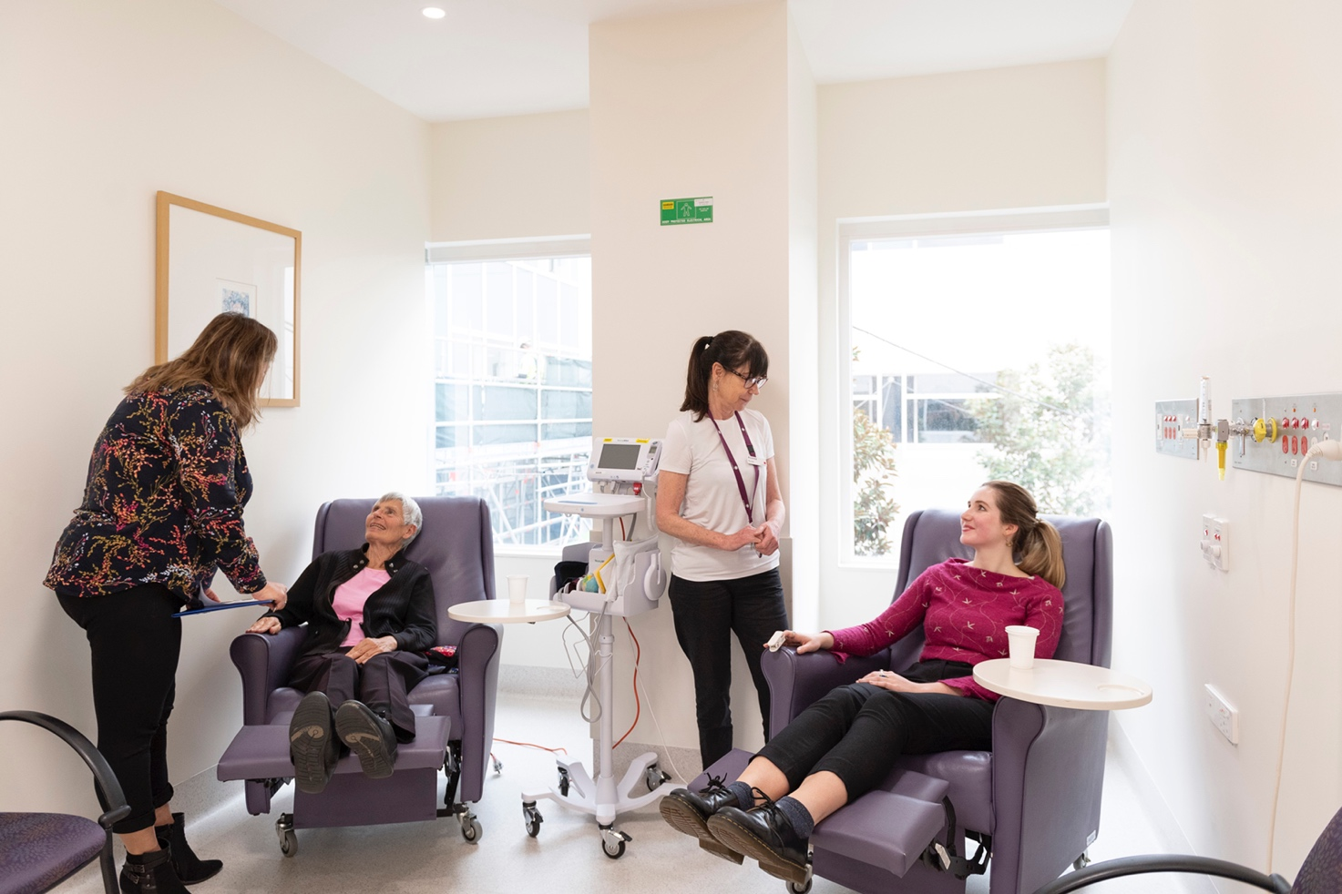
You said: Coming back into hospital with my newborn baby to assess and have a blood test for jaundice is burdensome and unsettling.
We acted: We equipped midwives who visit new mothers and babies in their homes to undertake blood tests. The test results are phoned through on the same day. Unless the baby needs treatment, no trips to the hospital are required.

You said: Unwrapping my baby while in the Special Care Nursery to look at their identification band is concerning – can’t the identification band go on the feeding tube?
We acted: Our staff now apply an identification label to the feeding tube as well as to the baby’s leg so that identifying the baby is easier and less disruptive.

You said: Monitoring my weight is important when attending antenatal appointments.
We acted: We installed more scales in accessible, discrete locations in our pregnancy clinics and we developed a range of resources to support a woman’s health and wellbeing during pregnancy.

You said: I don’t like having to rely on others to pick up our baby to feed whist I’m bedbound after a Caesarean.
We acted: We introduced purpose-designed sleeping tubs which are placed on a woman’s bed to keep her baby safe and close.

You said: Having my partner stay overnight is really helpful.
We acted: We provide single rooms and encourage partners to stay overnight whenever possible. This year we purchased chairs that recline to a fully-flat bed, allowing the option for a partner to sleep overnight in some shared double rooms.
Safety: Our people, patients, and culture
The Women’s recognises that a culture of quality and safety is critical to providing the best possible clinical care and patient experience.
We build quality and safety into everything we do, including our systems, processes, policies, procedures, education, resources and communications.
All Women’s staff and volunteers share responsibility for ensuring patient care is delivered safely and effectively.
We have checks in place to prevent errors and we review and learn from them when they do occur. Importantly, we focus on working as a team and having strong lines of communication that strengthen the partnerships between our people, patients and their families.

Note: Results have been calculated excluding ‘neither agree or disagree’ and ‘don’t know’ responses from the total responses received. The Women’s Annual Report 2019 presents results of the People Matter Survey 2018.
People matter most
Each year, our staff are invited to participate in the People Matter Survey conducted by the Victorian Public Sector Commission. The survey is for all employees in eligible public sector organisations and measures employee perspectives on topics such as safety, culture and leadership.
In May, 34 per cent of our workforce responded to the survey – exceeding the Department of Health and Human Services target of 30 per cent.
One of the dimensions in the survey focuses on patient safety and asks a number of questions about the patient safety culture at the Women’s, and how patient safety is assured and managed.
In 2019, our overall score for a positive patient safety culture was 90 per cent, above the target of 80 per cent. We believe this is the result of continued efforts over several years to improve patient safety structures and processes, as well as training requirements, changed staffing arrangements, and changes to our ongoing compliance monitoring arrangements.
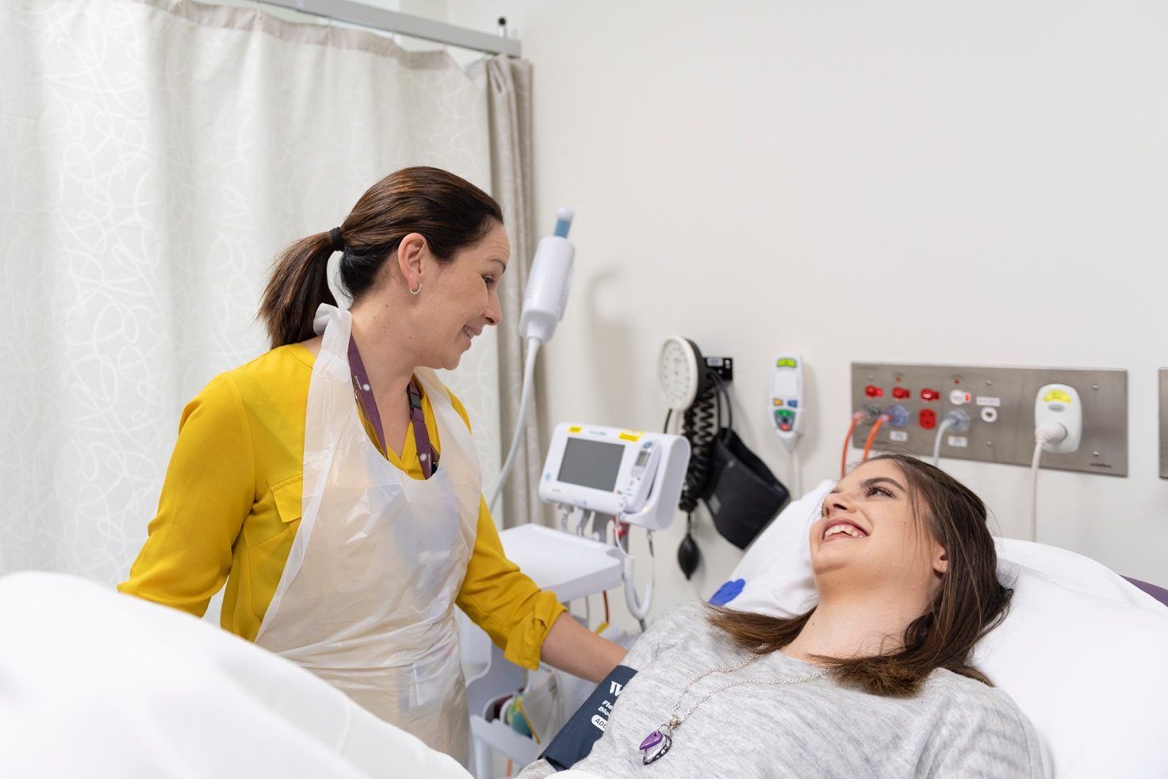
Air transfer devices a smart safety solution
The Women’s supports staff from across the organisation to raise safety concerns and 95 per cent of staff who responded to the People Matter Survey felt encouraged to report any concerns around safety.
This safety culture has led to the elimination of many hazards and the implementation of appropriate controls to remove or reduce the risk of injury.
With more than 900 procedures taking place in our surgical theatres each month, transferring patients from theatre tables to trolleys and from trolleys to beds can present a safety risk to staff – and also impact the comfort of patients.
Last year, theatre technicians identified the opportunity to adopt a safer and more comfortable and consistent approach to these transfers through the use of inflatable air transfer mats for all surgical patients.
Previously only used for the five per cent of our surgical patients who weigh more than 100 kilograms or have a BMI over 35, the mats allow for a slower, safer, cushioned transfer to trolleys and beds.
The introduction of air transfer mats for bariatric patients in early 2018 resulted in a 50 per cent reduction in patient transfer incidents. Extending their use to all surgical patients is expected to result in even fewer patient transfer incidents and improved physical safety of our staff and comfort of our patients.
“The mats are making it much easier to transfer patients, which is good for our backs. We only get one back and we really need to protect it. Manual handling can be a big risk for injuries but using the air transfer mats drastically lessens the risk, which is great.”
– Gary Kho, Theatre Technician at the Women’s
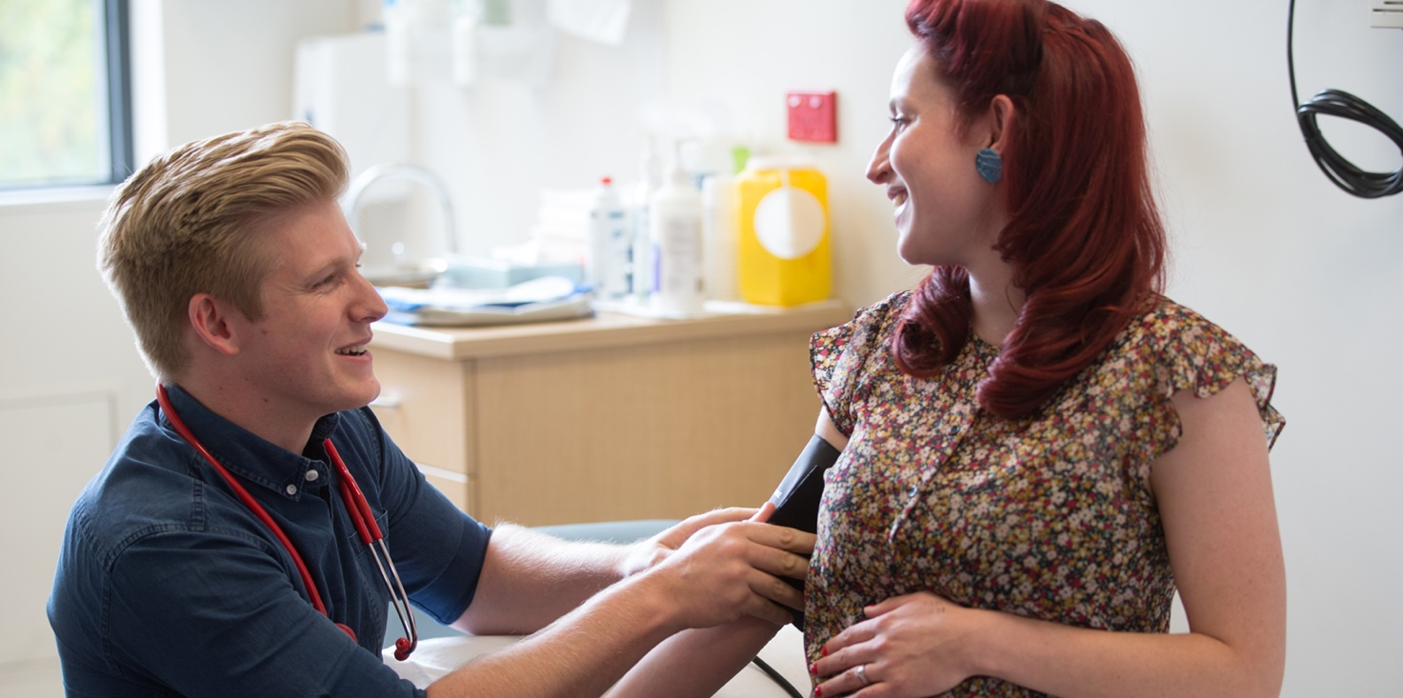
Accreditation achieved
In March, the Women’s was recognised for the high quality and safety of its care after we were assessed for accreditation by the Australian Council on Healthcare Standards (ACHS).
A team of independent assessors spent four days at the Women’s evaluating our performance in relation to the second edition of the National Safety and Quality Health Service Standards.
These new standards were developed by the Australian Commission on Safety and Quality in Health Care (ACSQHC) to provide a nationally consistent view about the standard of care consumers can expect from health services.
The assessors met with clinical and non-clinical leaders, other staff and patients from across the hospital, attended formal presentations, and reviewed our data and reports. They concluded that the Women’s met all 148 actions across eight standards.
The Women’s was the first Victorian hospital to be assessed against the new standards and we were very pleased to be awarded full accreditation by the ACHS. The fact that the Women’s achieved ACHS accreditation is strong recognition of the hard work and dedication of our staff across the organisation.
Sentinel and adverse events
Our goal is to always deliver the best and safest care for all patients, however the nature of what we do in hospitals is inherently risky. Whenever an adverse event occurs, we have a process for reporting, recording and investigating each one in order to learn from and prevent them from recurring.
Adverse clinical events are classified according to the severity of the outcome of the event. Events resulting in significant harm or death that are considered to have been fully preventable are called sentinel events. Other incidents are assigned an incident severity rating (ISR) between 1 and 4, with 1 being the most serious.
The Women’s conducts a root cause analysis or an in-depth review of all sentinel or serious adverse events. These review processes involve clinicians, senior managers and independent reviewers with relevant knowledge and expertise who focus on how and why the incident occurred and, where possible, recommend changes to prevent recurrences.
These recommendations are monitored as part of the clinical management and governance process and reported to the Management Quality and Safety Committee for action.
Sentinel and adverse events 2018/19
0  Sentinel events | 0  Incident Severity Rating 1 | 283  Incident Severity Rating 2
Infection control
Effective prevention and control of infection protects our patients, their families, visitors and our staff, and is an area of critical focus for the Women’s at all times.
Good hand hygiene is one of the crucial measures needed to prevent the spread of infections. All staff and volunteers at the Women’s are regularly informed of the importance of good hand hygiene through seasonal campaigns, mandatory training, and on-ward reminders and our hand hygiene program is supported by a large team of accredited auditors.
On the rare occasion when infections occur, we implement a variety of actions to manage the situation. Each case is promptly controlled, carefully monitored, and reviewed as a critical incident. We examine the risks and factors that contributed to the outcome, such as environment and process, and make best practice improvements using evidence-based methods.
Staphylococcus aureus bacteraemia (SAB)
SAB is a serious bloodstream infection that may be associated with hospital care. Hospitals aim to have as few cases as possible. The nationally agreed benchmark is no more than two SAB cases per 10,000 days of patient care for public hospitals. In Victoria, we aim for less than one case per 10,000 occupied bed days.
The Victorian Healthcare Associated Infection Surveillance Coordinating Centre (VICNISS) is responsible for collecting and analysing data on healthcare associated infections.

Central line-associated bloodstream infection (CLABSI)
A CLABSI is a serious infection that occurs when germs enter the bloodstream through a central line (a tube that is placed in a large vein, usually to give medication or fluids and to measure hydration).
Every effort is made to insert these lines under highly controlled conditions to prevent contamination and they are monitored closely whilst being used.

Flu immunisation the best defence
In the first half of 2019, rates of influenza in Victoria were ten times higher than the rate seen during the first half of 2018.
Flu immunisation protects both our people and patients. As we care for some of the most vulnerable in our community, we strongly encourage our staff to participate in our free influenza vaccination program.
DHHS sets a target of 84 per cent compliance for influenza vaccination among hospital staff. Our annual staff influenza campaign ran from 15 April to the end of July with 86.4 per cent of our staff vaccinated across both campuses at Parkville and Sandringham by 2 August, 2019.
For the first time, the Women’s at Parkville also participated in a campaign to encourage more pregnant women in our care to have their influenza and whooping cough vaccinations during pregnancy. The campaign was part of a Better Care Victoria Innovation Fund Project to improve vaccination rates for pregnant women in Victoria, and the Women’s at Parkville was one of six hospitals, and the only metropolitan health service, to take part in the project.
Pregnant women attending our clinics were able to get free vaccinations at a partnering pharmacy conveniently located nearby. Between 18 March and 20 August, 2,564 vaccines were administered – 1,099 for influenza and 1,465 for whooping cough. The success of this initiative will now see it integrated into permanent practice at the Women’s.
“When it comes to influenza, pregnant women are at a higher risk of severe disease and hospitalisation. An influenza vaccination given to a pregnant woman is currently the only way to protect her baby from flu in the first six months of its life. However, uptake of influenza and whooping cough immunisations by expectant mothers is low. Administering 2,564 vaccinations under this initiative was a great result and important step in protecting women and their newborns.”
– Associate Professor Michelle Giles,
Infectious Diseases Physician at the Women’s
Victorian Perinatal Services Performance Indicators
The Women’s is a significant provider of perinatal services – services to women and babies before and after birth. Each year, Safer Care Victoria produces the Victorian Perinatal Services Performance Indicators (PSPI) report to help improve outcomes for Victorian women and their babies.
The report contains data on ten performance indicators of perinatal care in Victorian health services. The indicators span the antenatal, intrapartum and postnatal periods and are measured at the state-wide public and private hospital level and at individual public hospital level.
Overall, the Women’s at Parkville performed very well, with five indicators rated in the most favourable quartile (compared to less than three for other tertiary hospitals). Improvement was noted for two indicators: gestation standardised perinatal mortality ratio for babies born at 32 weeks or more and the rate of term babies without congenital anomalies who require additional care.
Results for the Women’s Sandringham site were comparable to similar organisations, with two indicators rated in the most favourable quartile. Improvement was noted for two indicators: the rate of third-and-fourth-degree perineal tears in standard primiparae and the breastfeeding indicator.
Severe fetal growth restriction
Fetal growth restriction (FGR) is a condition in which a baby doesn’t grow to normal weight during pregnancy. FGR is a major area of focus in Victoria as it has been shown to be strongly and consistently associated with adverse perinatal outcomes.
PSPI Indicator 3 tracks the proportion of singleton babies with severe FGR born at or after 40 weeks’ gestation.
The Women’s rate is above the state-wide average, although at both Parkville and Sandringham we are now seeing fewer singleton babies with severe FGR delivered at 40 or more weeks’ gestation. This is due to a new initiative designed to detect babies with FGR that comprises a care program proposed by the Centre of Research Excellence in Stillbirth, Stillbirth and Neonatal Death Alliance, and Perinatal Society of Australia and New Zealand.

The initiative involved:
- staff education to promote a standardised way of measuring
the symphyseal-fundal height
(SFH – the height from the top of the mother’s uterus to the top of the mother’s pubic joint)
- introducing growth charts to all teams to plot and evaluate SFH growth patterns
- greater emphasis on individualising fetal growth monitoring to the woman’s risk factors.
Collectively, these interventions are known as PaMPER – Palpate, Measure, Plot, Evaluate and Refer. Posters reminding staff of these interventions were created and are in every clinic room in Parkville and Sandringham. Growth charts were also made available in every clinic room and have recently been enhanced to include a growth chart to plot estimated fetal weight by ultrasound.
In addition, a robust review process for FGR babies takes place weekly at our clinical meetings and senior management level, and regular feedback is provided to clinicians following case reviews.
Low Apgar score
PSPI Indicator 10 measures the wellbeing of babies who are born at 37 or more weeks’ gestation and without congenital anomalies at birth.
The Apgar score is an assessment of a newborn’s wellbeing at birth based on five physiological attributes at one and five minutes (and longer if applicable); colour (circulation), breathing, heart rate, muscle tone, and reflexes. It is used as a proxy for the quality of care provided during labour and delivery, and neonatal resuscitation (if necessary) following birth.
Each of the five attributes is given a score of 0, 1 or 2, with a combined total maximum score of 10. The higher the score, the better the baby is doing after birth. An Apgar score below 7 at five minutes indicates a baby requires ongoing resuscitation measures or additional care. Singleton babies (a baby born of a single birth) who are more than 37 weeks’ gestation and without congenital anomalies are expected to be born in good condition, show healthy transition at birth, and not require resuscitation.
The Women’s monitors all Apgar scores at both Parkville and Sandringham, reviewing every baby born with an Apgar less than 7 at five minutes. Monthly data is presented to clinicians and tracked on our dashboards. Every baby with a low Apgar score is reviewed by a multidisciplinary panel with obstetric, midwifery and neonatal paediatric representation.
The panel reviews the mode of birth, FGR, length of labour, pain management during labour, epidural management and anaesthetic, length of second stage and other relevant clinical criteria.
The rate of term babies without congenital anomalies with an Apgar score under 7 at five minutes has risen at Parkville and Sandringham in the last year. This has resulted in an increase in term babies who require additional care at both sites. The rate is equivalent to the state-wide public performance and no recurrent issues or themes have been identified in the review process.
We continue to take action to reduce the number of term babies without congenital anomalies with an Apgar score below 7 through initiatives such as the Sandringham Improving Labour Outcomes and Responses (SaILOR) project, introduced in January.
SaILOR is designed to reduce the number of women with prolonged labour and therefore the rates of postpartum haemorrhage and third and fourth degree tears by educating staff about the importance of labour diagnosis and use of labour and birth decision aids to support decision-making. It is anticipated that SaILOR’s more standardised approach to the management of labour will positively impact Apgar scores.

Leading the way in women’s healthcare
During 2018/19, the Women’s continued to lead the Regional Maternal and Perinatal Mortality and Morbidity Committee (RMPMMC) initiative. The RMPMMC initiative, resourced by DHHS, commenced in 2016 and is centrally coordinated by the Women’s in partnership with rural and regional health services. The program has established a culture and practice of independent peer review, systematic analysis, and multidisciplinary governance of quality and safety issues in maternal and newborn health across Victoria.
We also continued our successful state-wide Maternity Services Education Program (MSEP), which aims to enhance maternity practice across regional and rural Victoria. During the year, this accredited education program presented 23 workshops across Victoria and reached 430 health workers.
MSEP also worked with the East Gippsland Community Based Internship program to provide maternity emergency training to interns, midwives and general practitioners.
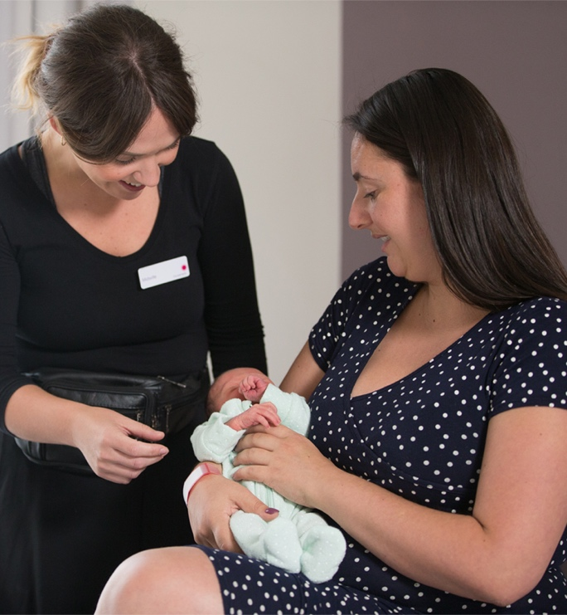
Escalation of care processes
In October 2016, the Women’s implemented a Patient Initiated Medical Emergency Team (MET) service to support an appropriate and timely response to a patient in the event of their condition deteriorating as observed by themselves, a carer, relative and/or friend. The Patient Initiated MET is now embedded into our emergency response framework.
Almost three years after implementation, only five Patient Initiated MET calls have been made in total. Regular audits indicate that patients are aware of the system and how to place the call, and that all signage is in place. Mock Patient Initiated MET calls are regularly undertaken to ensure appropriate responses.
Example of Patient Initiated MET call process
Patient receives explanation of MET call process on admission and signage is visible on bedside and in ensuite bathrooms

Patient is concerned about herself or her baby so she activates nurse/midwife call bell

After no immediate response patient uses bedside phone to dial 2999

Dedicated switchboard line answers and broadcasts MET call twice throughout hospital

MET attends for immediate assessment and response – no intervention required but patient’s concerns listened to and support and reassurance provided

Details recorded in Medical Record and Victorian Health Incident Management System

Case reviewed at bi-monthly Emergency Medical Response Committee
Simple guide helps parents identify when to act
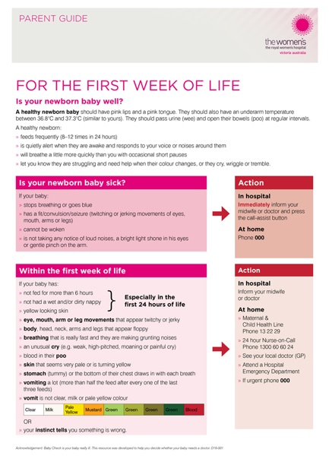
The Women’s provides all new parents with a copy of our Parent Guide For the First Week of Life.
The simple single-page guide assists parents in how to recognise and respond to any deterioration of a previously healthy newborn.
The guide was developed in consultation with consumers and is available statewide.
“Clear, easy to read, not too much information. Well done – a good resource.”
– Consumer feedback on our Parent Guide For the First Week of Life
Embedding patient and consumer perspectives in governance
The Women’s Board Community Advisory Committee
Appointed by, and reports to, the Women’s Board of Directors.
Purpose: To advise the Women’s on establishing and maintaining effective systems to ensure we meet the needs of the communities we serve, and that the views of women are taken into account in the hospital’s decision making processes.
Chair: Ms Christina Liosis (retired from Board June 2019)
Director: Ms Mandy Frostick
Members: Ms Deepa Mathews, Ms Heather Beanland (resigned May 2019), Ms Rebecca Harris (resigned February 2019), Ms Charlene Edwards, Ms Alison Soutar, Ms Ivy Wang, Mr Simon Gullery, Ms Lorraine Parsons, Ms Heikma Siraj
The Women’s Board Quality and Safety Committee
Appointed by, and reports to, the Women’s Board of Directors.
Purpose: To facilitate improved outcomes for patients by ensuring that systems are in place to promote and monitor the improvement of the quality of clinical and other services and to enhance the safety of clinical care.
Chair: Dr Nicolas Radford AM (retired from Board June 2019)
Directors: Ms Lyn Swinburne AO, Ms Cath Bowtell, Ms Naomi Johnston (from August 2018)
Members: Dr Jack Bergman, Mr Simon Gullery (from August 2018), Ms Amelia Jalland (from February 2019)
Patient and Consumer Experience Steering Committee
Appointed by, and reports to the Women’s Community Advisory Committee and the Women’s Chief eXperience Officer.
Purpose: To assist the Women’s in delivering on our key strategic direction to provide an exceptional patient and consumer experience that offers improved health outcomes for women and newborns. To provide advice and recommendations on a number of patient experience topics.
Chair: Ms Christina Liosis (retired from Board June 2019)
Director: Ms Mandy Frostick
Members: Ms Deepa Mathews, Mr Simon Gullery, Ms Heikma Siraj, Ms Lorraine Parsons, Ms Alison Soutar, Ms Charlene Edwards, Ms Ivy Wang, Ms Heather Beanland (retired from Committee May 2019), Ms Bev O’Sullivan,
Ms Kathryn Cruickshanks, Dr Louise Owen, Ms Julie Kuypers, Ms Jen Scantlebury
Abbreviations and glossary
ACHS – Australian Council on Healthcare Standards
ACSQHC – Australian Commission on Safety and Quality in Health Care
CEE – Creating Exceptional Experiences
CLABSI – Central line-associated bloodstream infection (occurs when germs enter the bloodstream through the central line – a tube that is placed in a large vein, usually to give medication or fluids and to measure hydration)
DHHS – Department of Health and Human Services
EMR – Electronic Medical Record
FGR – Fetal growth restriction (a condition in which a baby doesn’t grow to normal weight during pregnancy)
MET – Medical Emergency Team
MSEP – Maternity Services Education Program
PSPI – Perinatal Services Performance Indicators
RMPMMC – Regional Maternal and Perinatal Mortality and Morbidity Committee
SAB – Staphylococcus aureus bacteraemia (a serious bloodstream infection)
SFH – Symphyseal-fundal height (the height from the top of the mother’s uterus to the top of the mother’s pubic joint)
VICNISS – Victorian Healthcare Associated Infection Surveillance Coordinating Centre
Antenatal – The period of time during pregnancy
Apgar score – An assessment of a newborn’s wellbeing at birth based on five physiological attributes at one and five minutes; colour (circulation), breathing, heart rate, muscle tone, and reflexes
Bariatric – Describes the medical treatment of obesity
Bilirubin – An orange-yellow pigment that occurs normally when red blood cells break down
BMI – Body Mass Index (one method used to estimate a person’s total amount of body fat)
Consumers – People who use health services, as well as their family and carers
Discharge – When a patient leaves hospital for home
Health literacy – The degree to which individuals have the capacity to obtain, process, and understand basic health information and services needed to make appropriate health decisions
Inpatient – A patient who receives treatment while staying in the hospital
Intrapartum – The period of time spanning childbirth, from the onset of labour through delivery of the placenta
Multidisciplinary teams – Team made up of a range of health professionals, from one or more organisations, working together to deliver comprehensive patient care
Outpatient – A patient who is not hospitalised overnight but who visits a hospital, clinic, or associated facility for diagnosis or treatment
People Matter Survey – Annual survey conducted by the Victorian Public Sector Commission for all employees in eligible public sector organisations
Perinatal – The period of time before and after birth
Perineal tears – A tear in the area between vaginal opening and anus (which can happen during childbirth)
Postnatal – The period of time after birth
Primiparae – An individual who is giving birth for the first time
Singleton – A baby born of a single birth
Tertiary hospital – Australia has a three-tiered healthcare system, with healthcare providers falling in to one of three categories: primary, secondary and tertiary healthcare. Highly specialised healthcare, often for inpatients and on referral from a primary or secondary health professional, is considered tertiary care. This often includes particularly complex medical or surgical procedures.



